1. To list all records with sal > 2000 and comm>200

Ans. Select *

From emp

Where sal>2000 and comm>200;

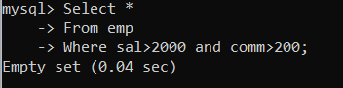

1. To list all record with job=“Clerk” or sal>2000

Ans.

Select *

From emp

Where job =“clerk” or sal>2000;

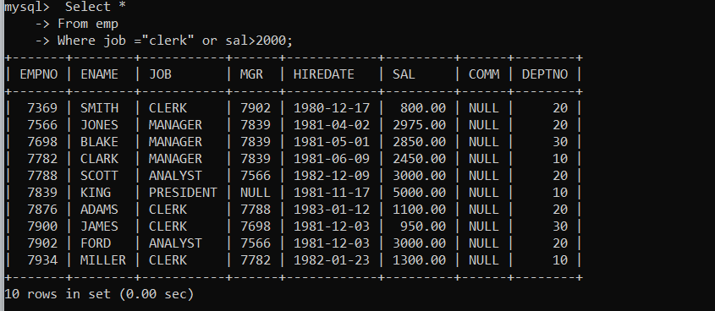

1. To list all the record with sal=1250 or 1100 or 2850

Ans.

Select*

From emp

Where sal in (1250,110,2850);

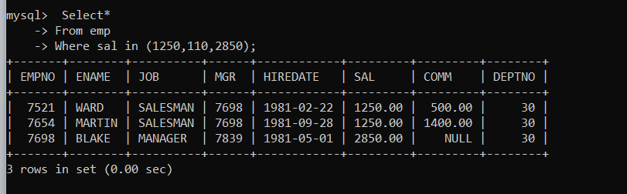

1. To list all employees with sal>1250 and <2850

Ans.

Select*

From emp

Where sal between 1250 and 2850;

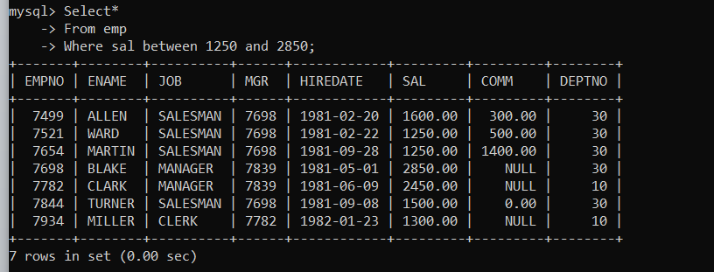

1. To list all employees with name ends with AS

Ans.

Select*

From emp

Where ename like “%AS”;

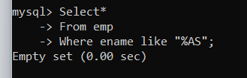

1. To list all employees with job starts with C and ends with K

Ans.

Select*

From emp

Where ename like “C%K”;

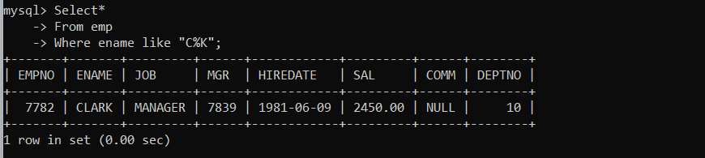

7. To list all employees with job contains L at third position and M at third last position.

Select *

From emp

Where ename like “__L%M__”;

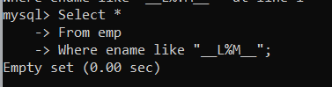

8. To list all the record with sal not equal to 1250 or 1100 or 2850

Ans.

Select*

From emp

Where sal not in (1250,1100,2850);

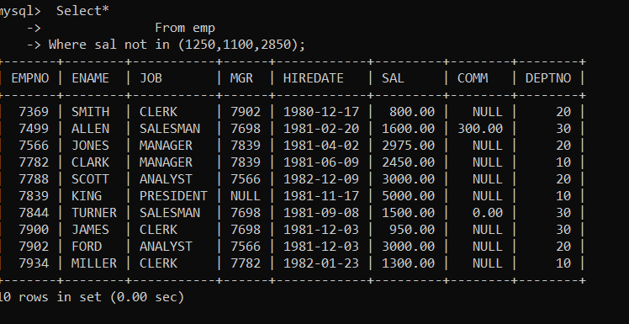

9. To list all employees with salnot >1250 and <2850

Ans.

Select*

From emp

Where sal between 1250 and 2850;

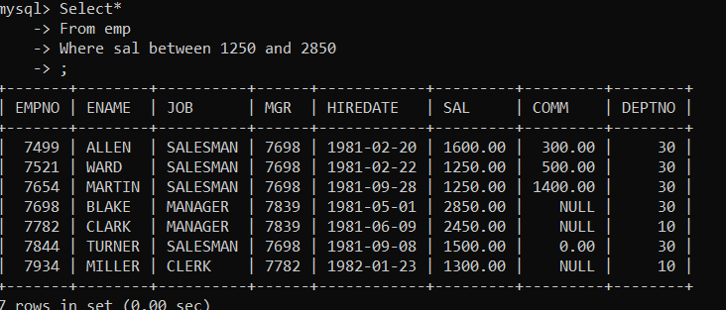

10. To list all employees with job starts with C , E at 3rd position and ends with K

Ans.

Select *

From emp

Where job like “C_E%K”;

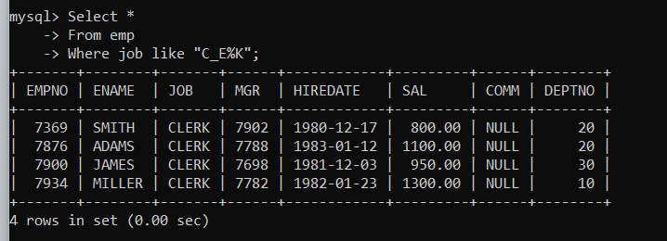

11. To list all rows with comm is null

Ans.

Select *

From emp

Where comm=null;

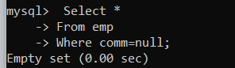

12. To list all employees with sal is null and name starts with “S”

Ans.

Select *

From emp

Where ename like “S%” and sal = null;

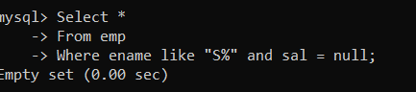

13. To list all employees with job contains 5 characters.

Ans.

Select *

From emp

Where length(job)=5;

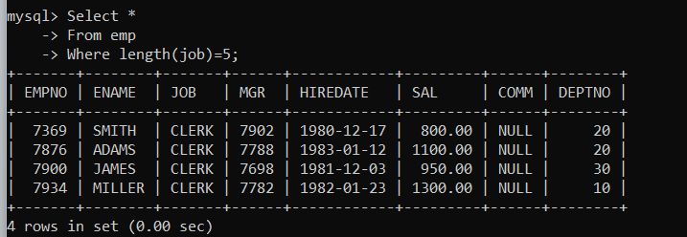

14. To list all employees with name contain “A” at 1 position and job

Contains 5 characters.

Ans.

Select *

From emp

Where ename like “A” and length(job)=5;

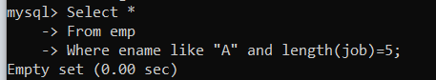

Q2. Solve the following

1. Retrieve the details (Name, Salary and dept no) of the emp who are working in

department code 20, 30 and 40.

Ans. Select ename NAME, sal SALARY,deptno “DEPT. NO.”

From emp

Where deptno in (20,30,40);

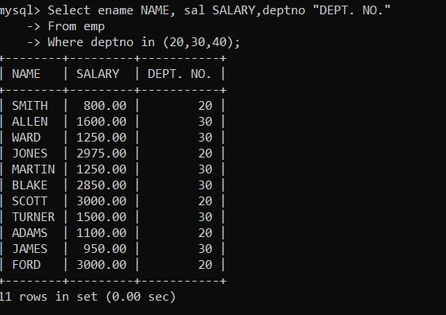

2. Display the total salary of all employees . Total salary will be calculated as

sal+comm+sal*0.10

Ans. select *,Round(sal+ifnull(comm,0)+sal*0.10,2) “Net Salary”

from emp;

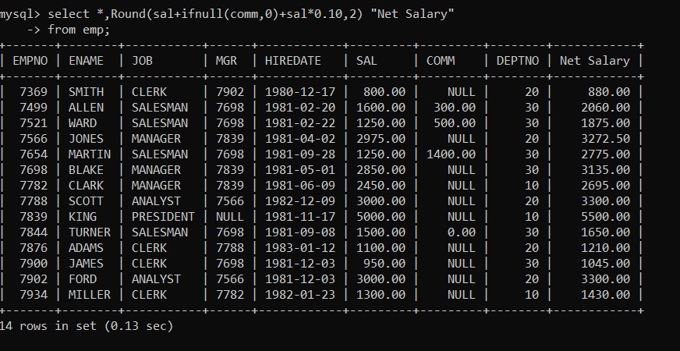

3. List the Name and job of the emp who have joined before 1 jan 1986 and whose

salary range is between 1200and 2500. Display the columns with user defined Column

headers.

Ans. Select ename NAME, job JOB

From emp

Where year( hiredate)<1986 and sal between 1200 and 2500;

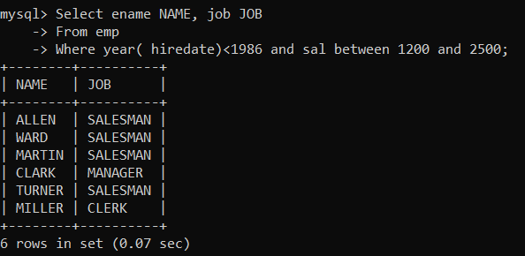

4. List the empno, name, and department number of the emp works under manager

with id 7698

Ans. SELECT EMPNO “EMPLOYEE NUMBER”,ENAME “EMPLOYEE NAME”,DEPTNO “DEPARTMENT NUMBER”

FROM EMP

WHERE MGR =7698;

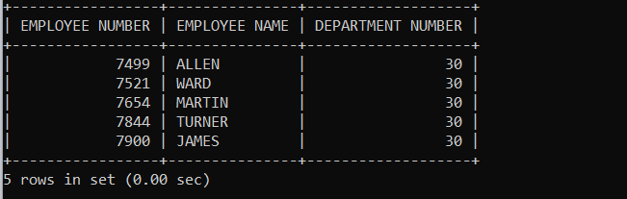

5. List the name, job, and salary of the emp who are working in departments 10 and

30.

Ans. Select ename name, job,sal salary

From emp

Where deptno in (10,30);

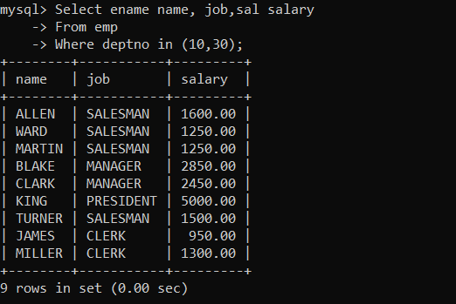

6. Display name concatenated with dept code separated by comma and space. Name

the column as “Emp info”.

Ans. Select concat(ename,”, “,deptno) “Emp info”

From emp;

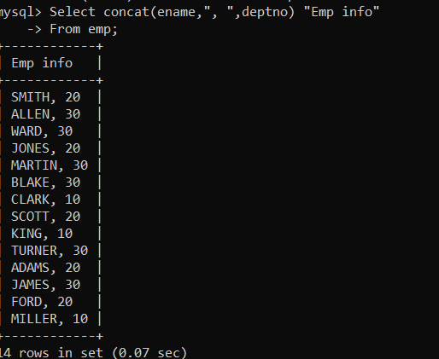

7. Display the emp details who do not have manager.

Select *

From emp

Where MGR is null;

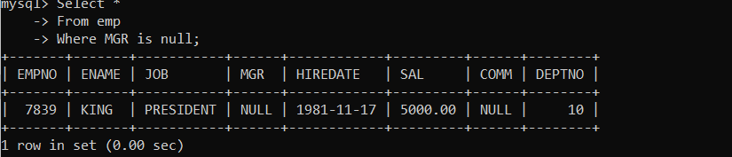

8. Write a query which will display name, department no and date of joining of all

employee who were joined January 1, 1981 and March 31, 1983. Sort it based on date of

joining (ascending).

Ans.

Select ename name ,deptno “Department No.”,hiredate “Date of Joining”

From emp

Where day (hiredate) between 1 and 31 and month(hiredate) between 1 and 3 and year(hiredate)=1981;

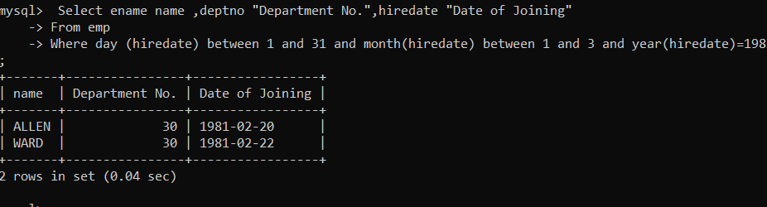

9. Display the employee details where the job contains word “AGE” anywhere in the Job

Ans.

Select *

From emp

Where job REGEXP “^.*AGE.*$”;

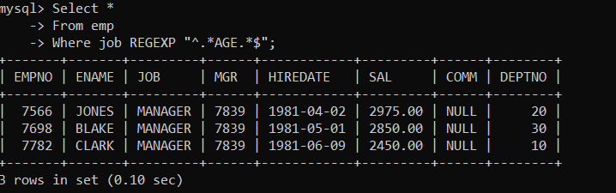

11. List the details of the employee , whose names start with “A” and end with “S” or

whose names contains N as the second or third character, and ending with either “N” or “S”.

Ans.

select *

from emp

where ename REGEXP “^A.*S$”|”^..?N.*?[NS]$”;

12. List the names of the emp having “_” character in their name.

Select *

From emp

Where ename REGEXP “^.*_.*$”;

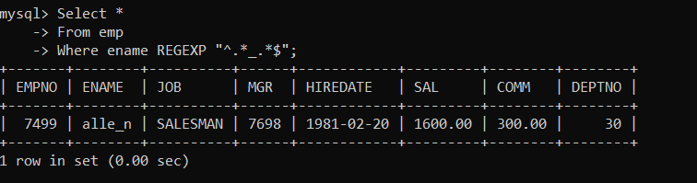

Single Row functions

1. To list all employees and their email, to generate email use 2 to 5 characters from ename

Concat it with 2 to 4 characters in job and then concat it with “@mycompany.com”

Ans. Select ename Name, concat(substr(ename,2,3),concat(job,2,4),”@mycompany.com”) “Email”

From emp;

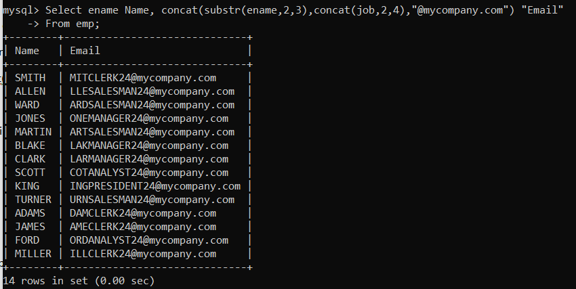

2. List all employees who joined in September.

Ans. Select *

From emp

Where month(hiredate)=9;

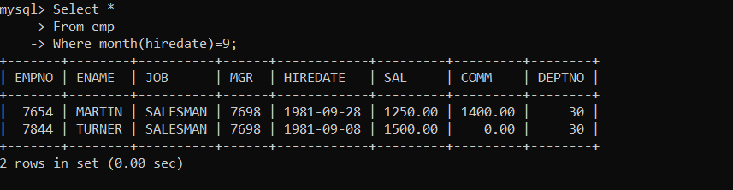

3. List the empno, name, and department number of the emp who have experience of 18 or

more years and sort them based on their experience.

Ans. Select empno “Emp. No.”, ename NAME, deptno “Department No.”

From Emp

Where floor ((datediff(curdate(),hiredate))/365) > 18;

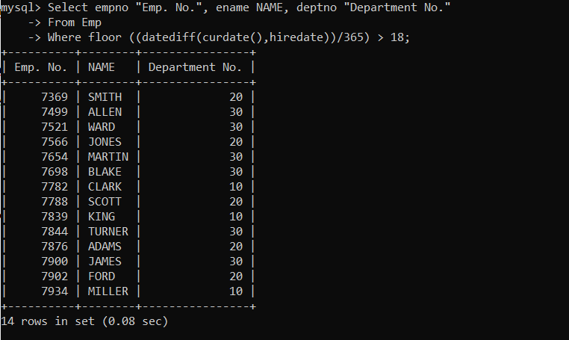

4. Display the employee details who joined on 3rd of any month or any year

Ans. Select *

From emp

Where day (hiredate)=3;

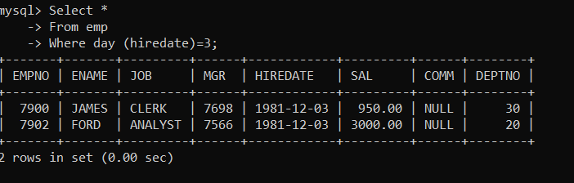

5. display all employees who joined between years 1981 to 1983.

Ans. Select *

From emp

Where year(hiredate) between 1981 and 1983;

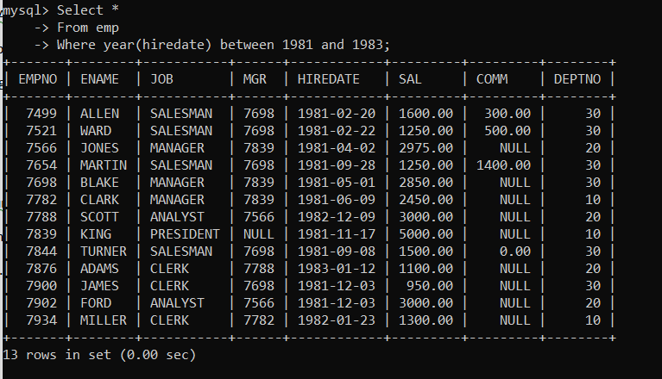

Group functions

6. Display the Highest, Lowest, Total & Average salary of all employee. Label the columns

Maximum, Minimum, Total and Average respectively for each Department. Also round the

result to the nearest whole number.

Ans. Select deptno,round(max(sal),0) Highest ,round(min(sal),0) Minimum ,round(sum(sal),0) Total, round(avg(sal),0) Average

From emp

Group by deptno

Order by deptno;

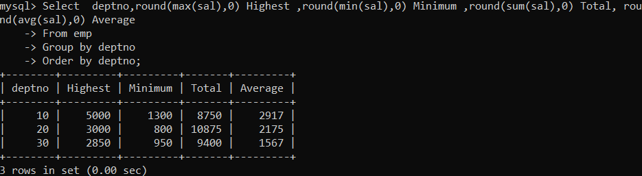

7. Display Department no and number of managers working in that department. Label the

column as “Total Number of Managers” for each department.

Ans. Select deptno, count(*) “no. of managers”

From emp

Where job=“manager”

Group by deptno

Order by deptno;

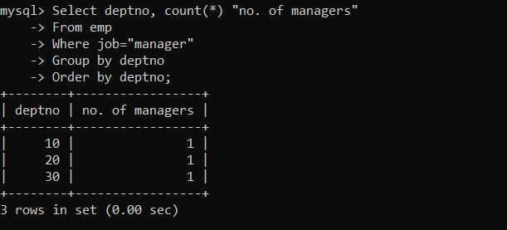

8. Get the Department number, and sum of Salary of all non managers where the sum is

greater than 20000.

Ans.

Select deptno, sum(sal)

From emp

Where job != “manager and sum(sal) >20000”

Group by deptno;

